

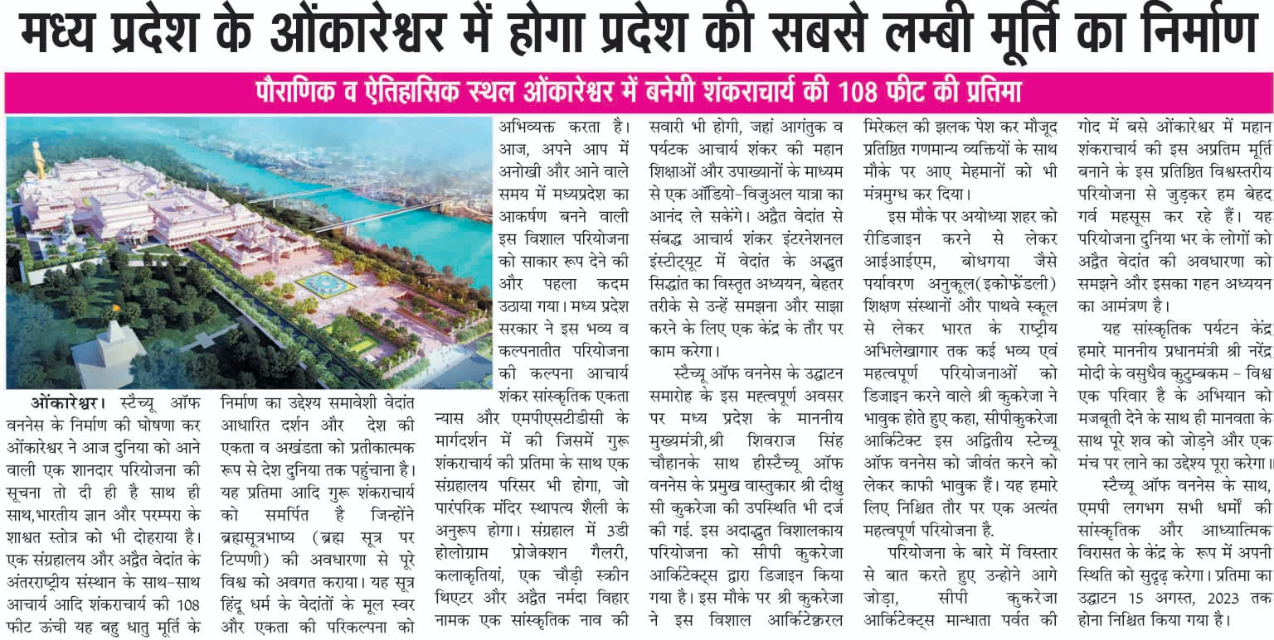

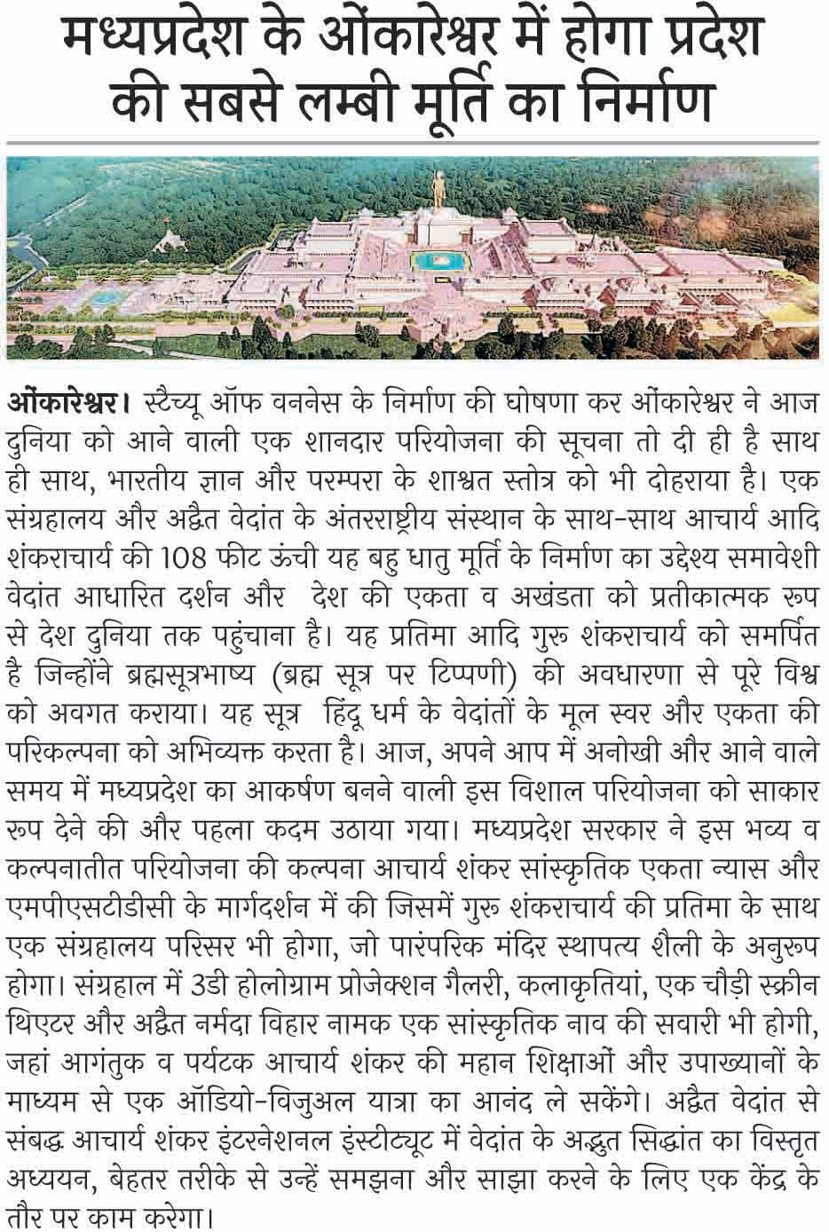



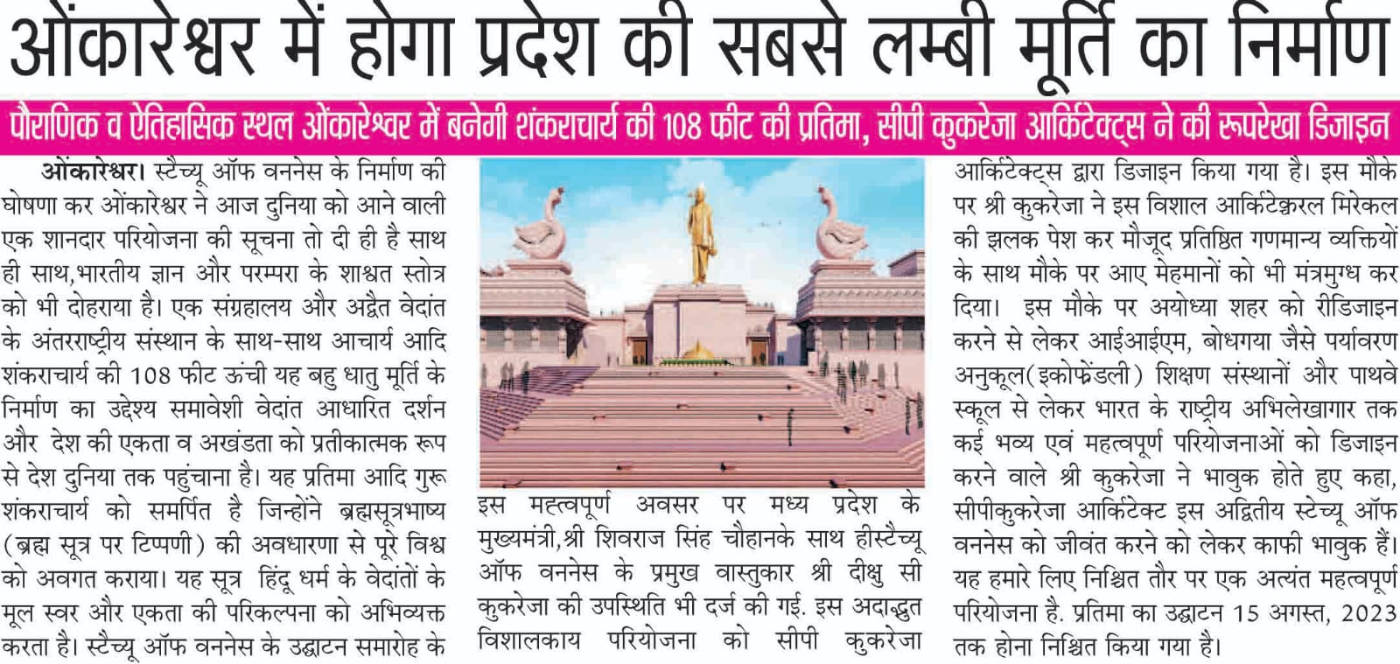

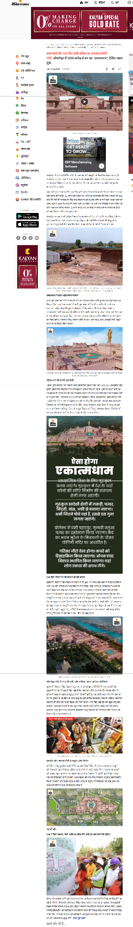
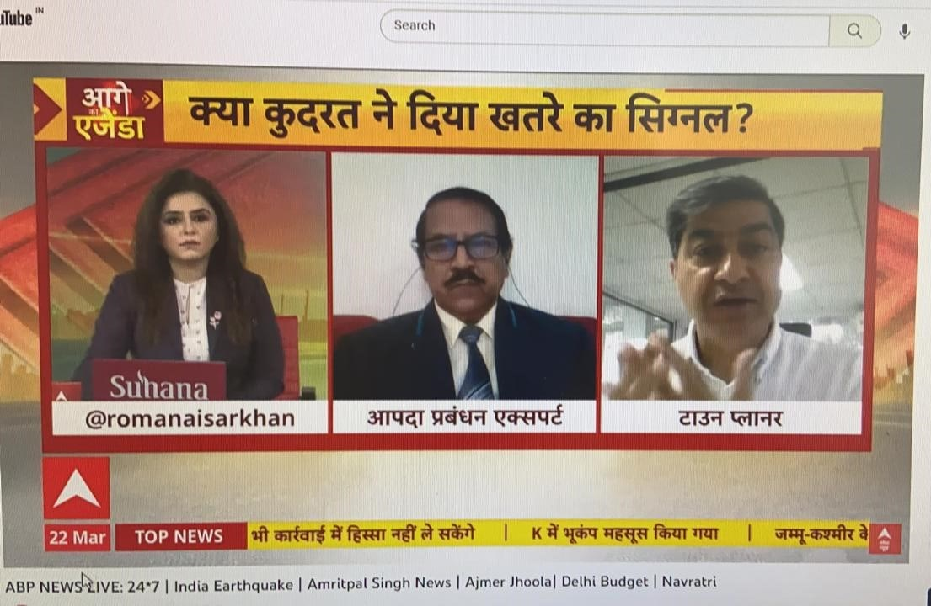

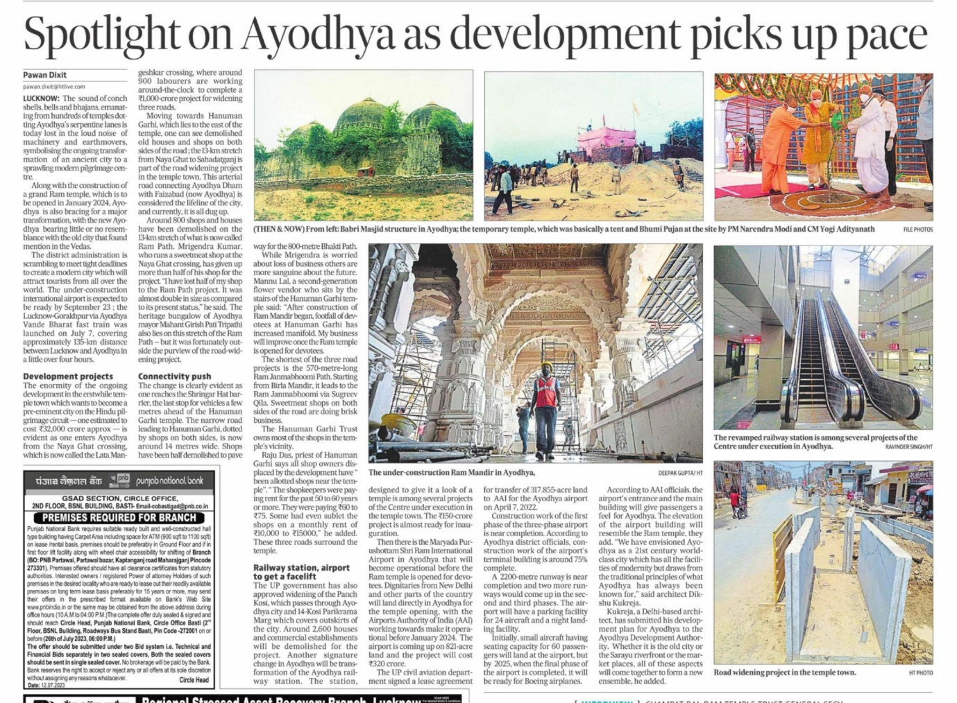

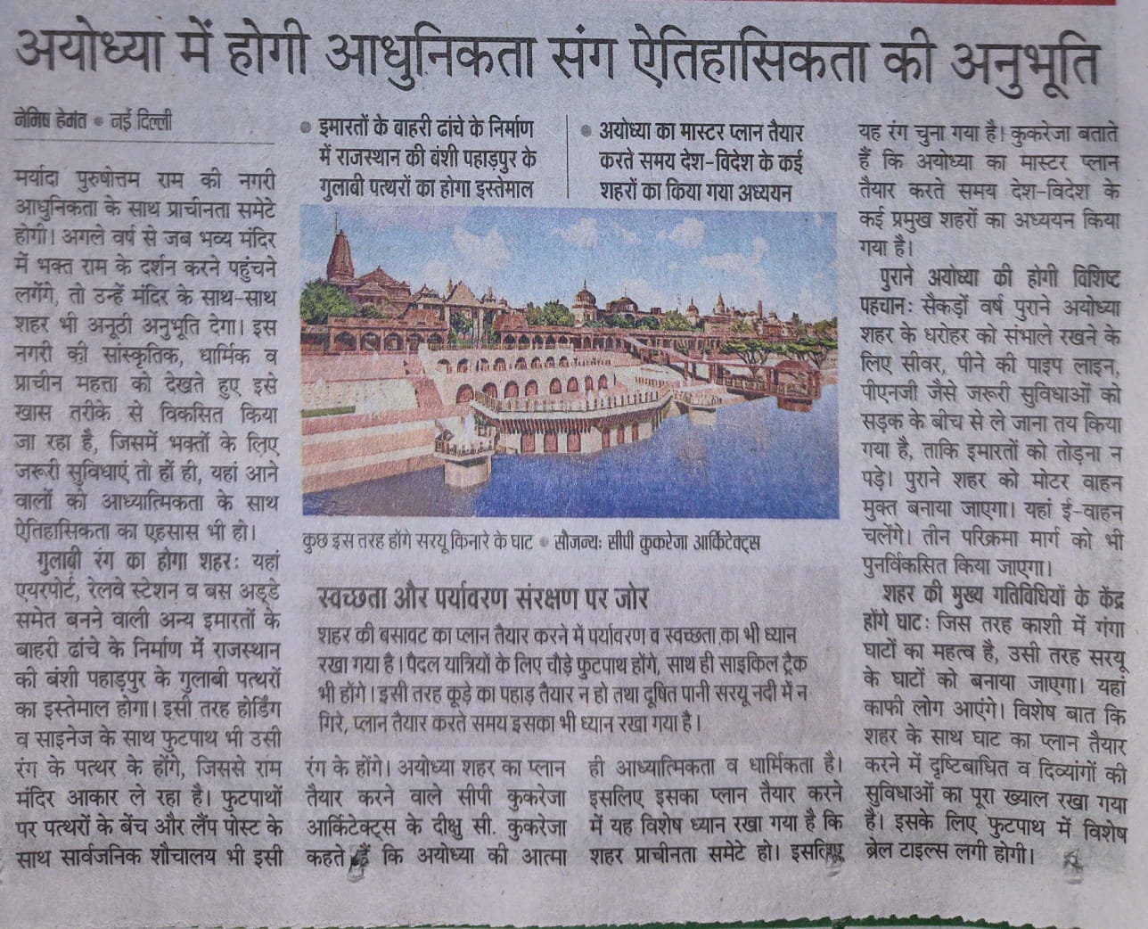

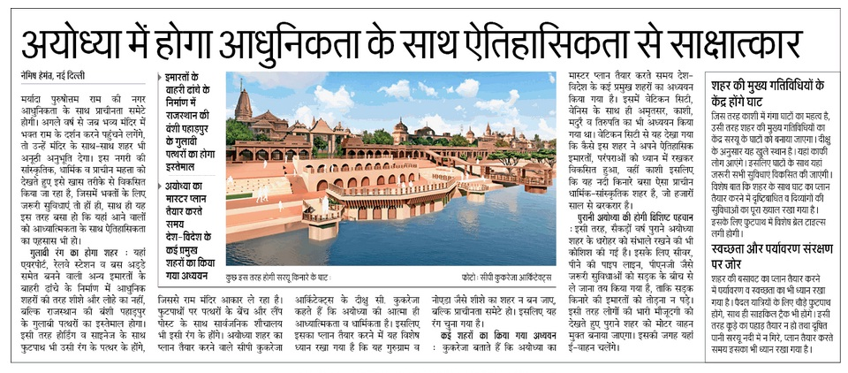

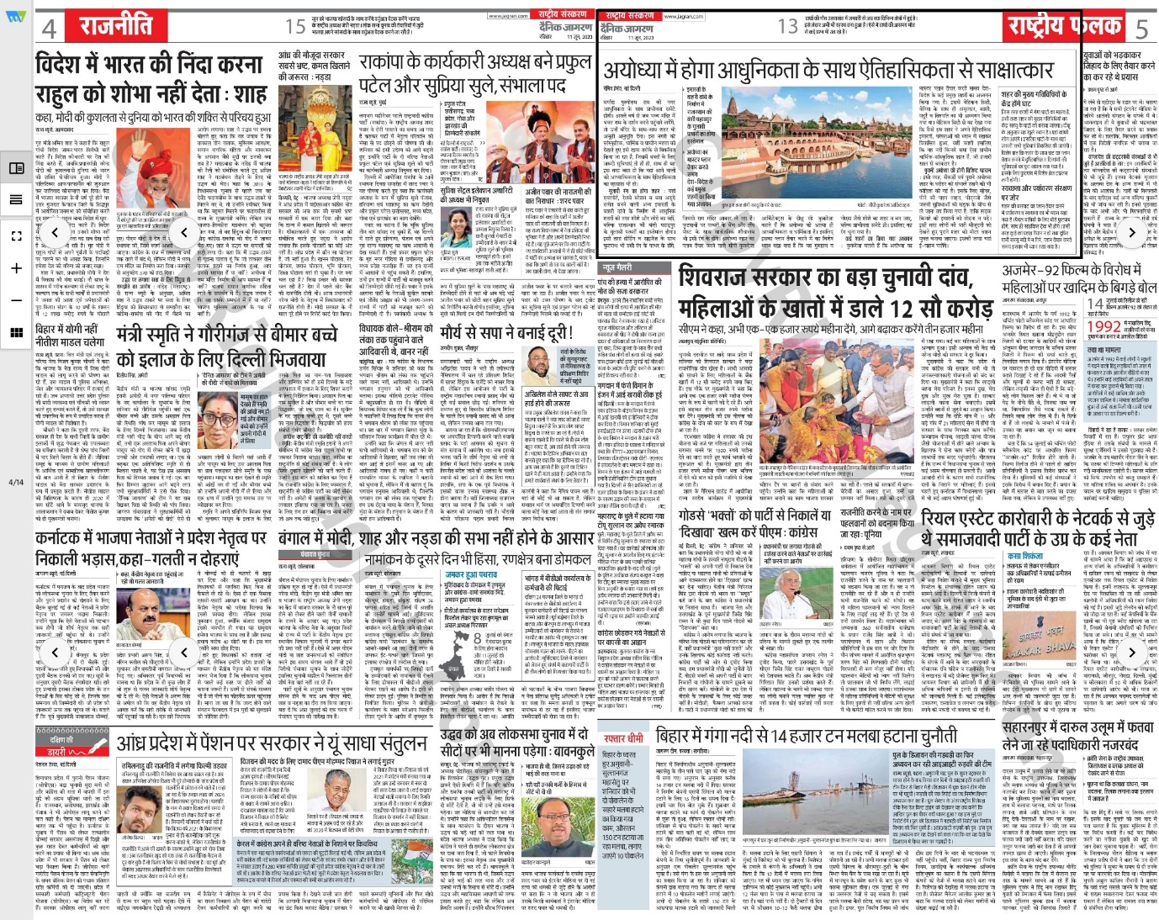

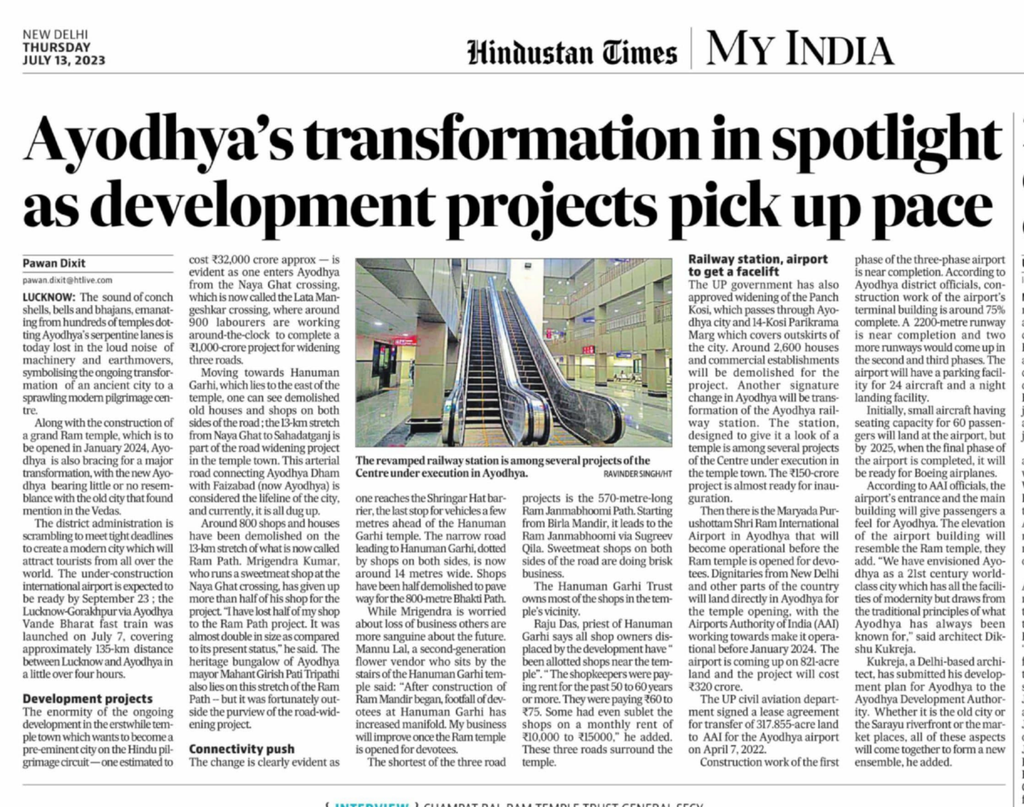

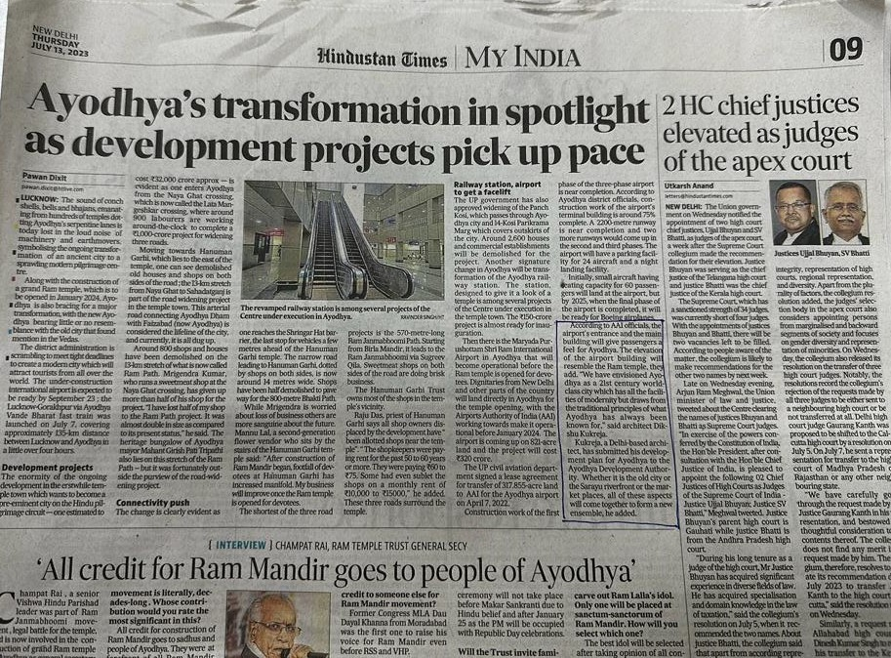

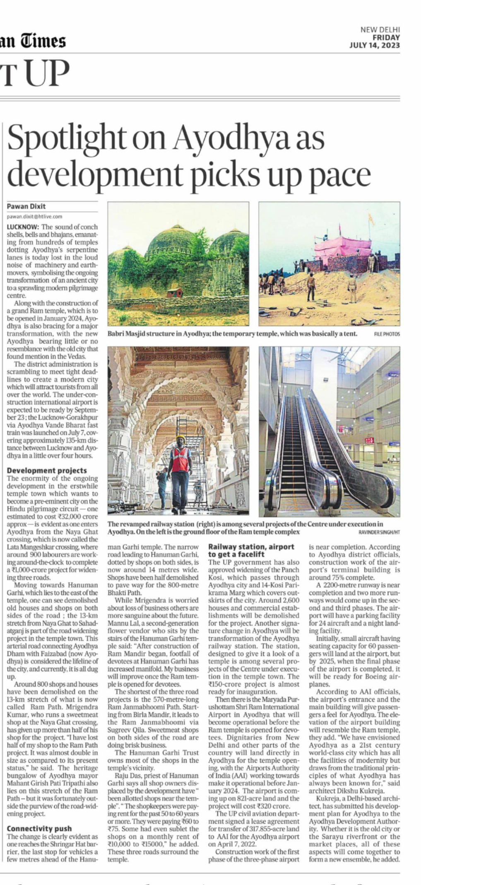

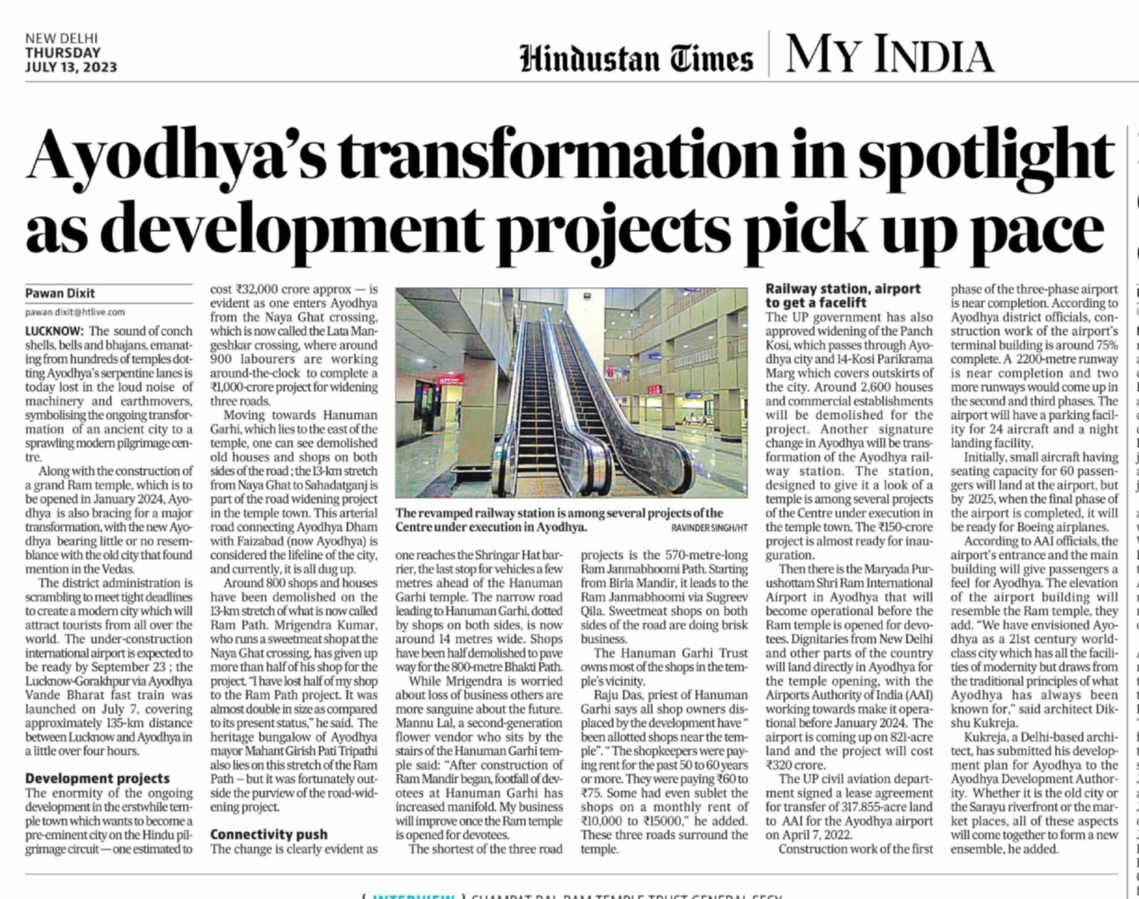




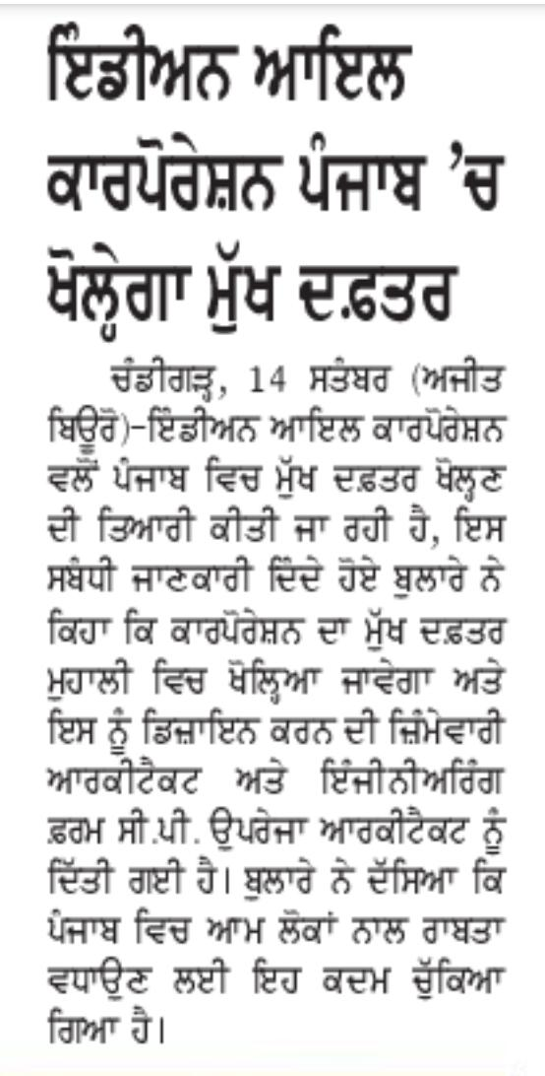
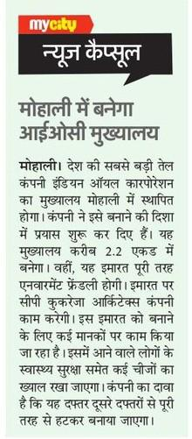

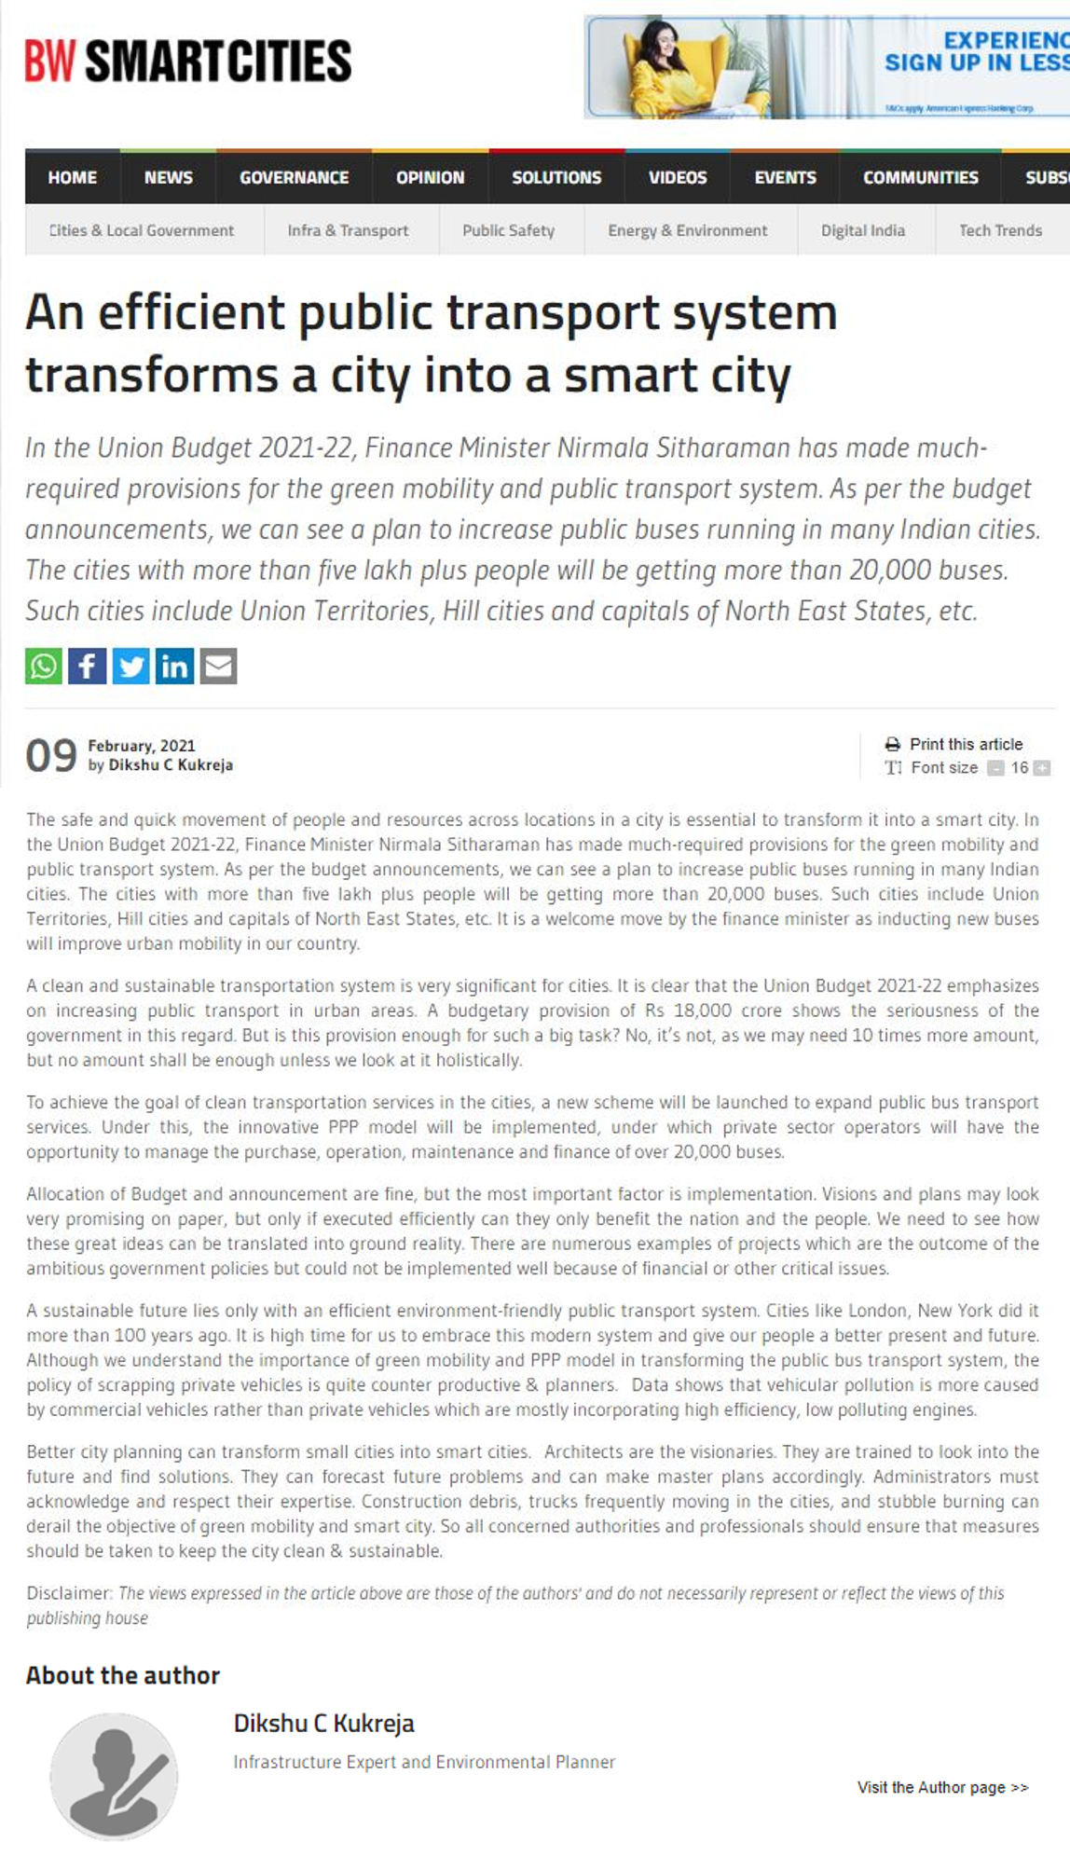




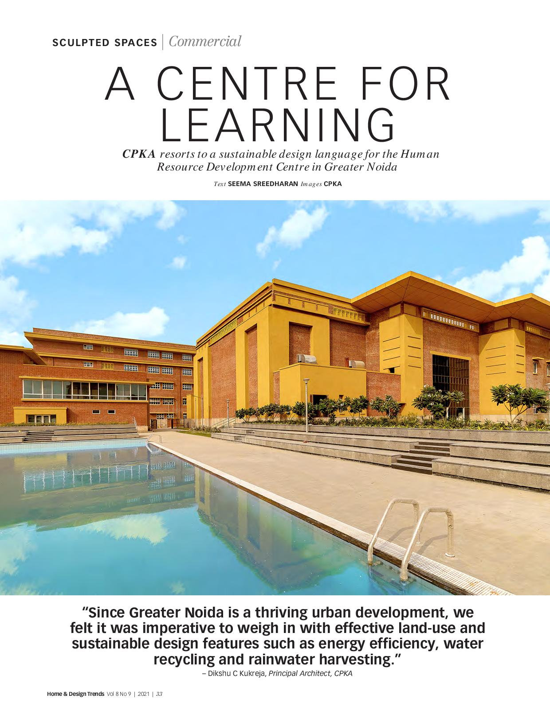
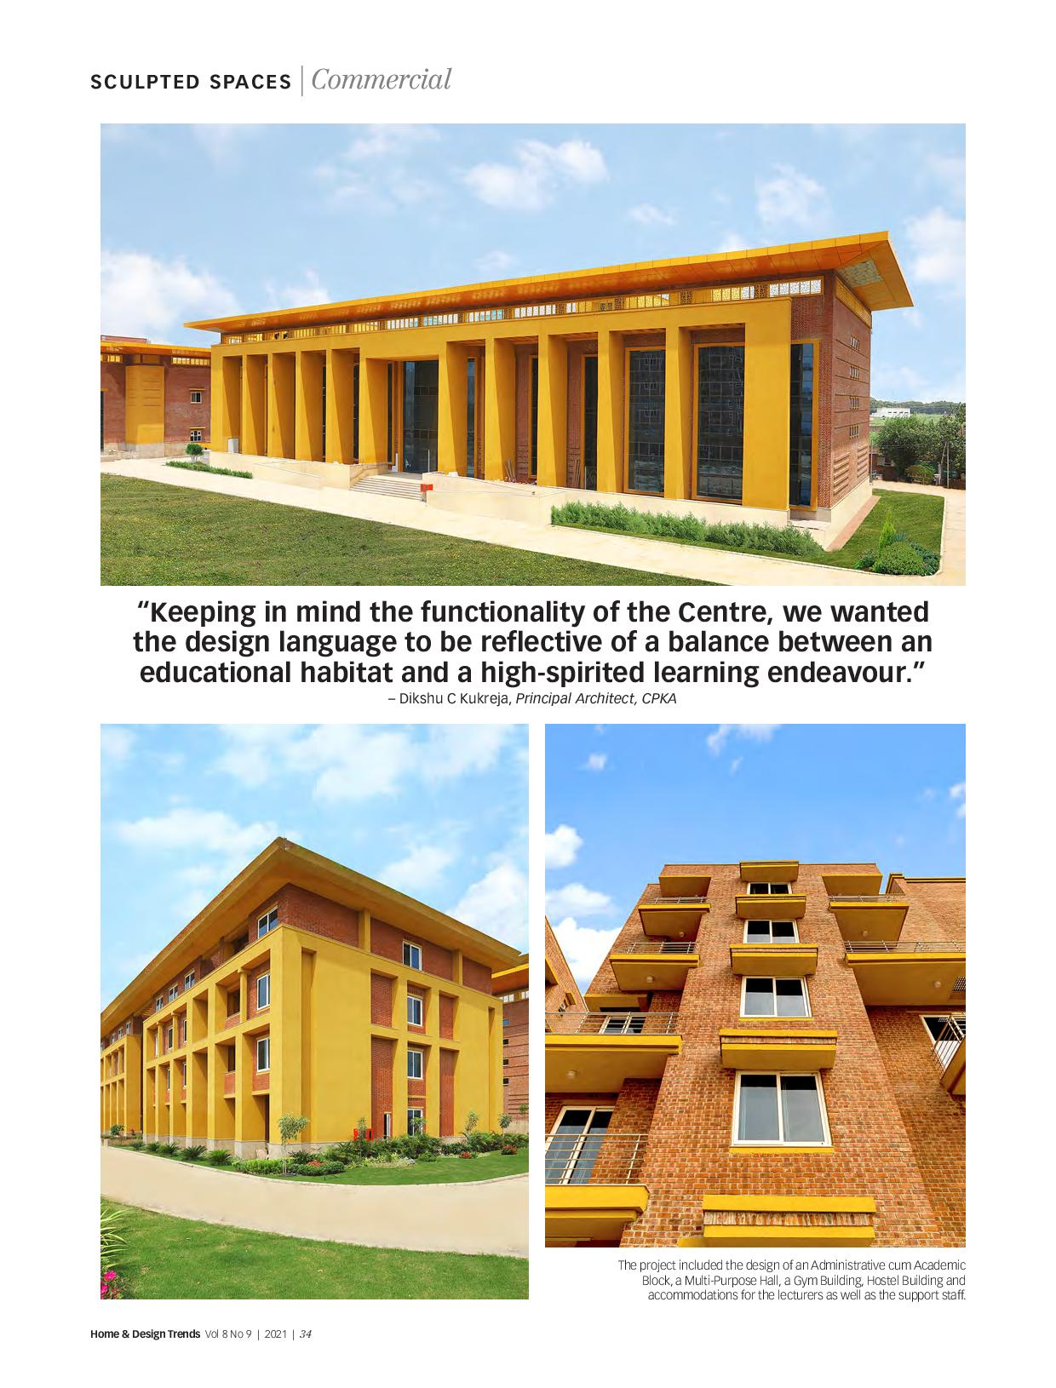
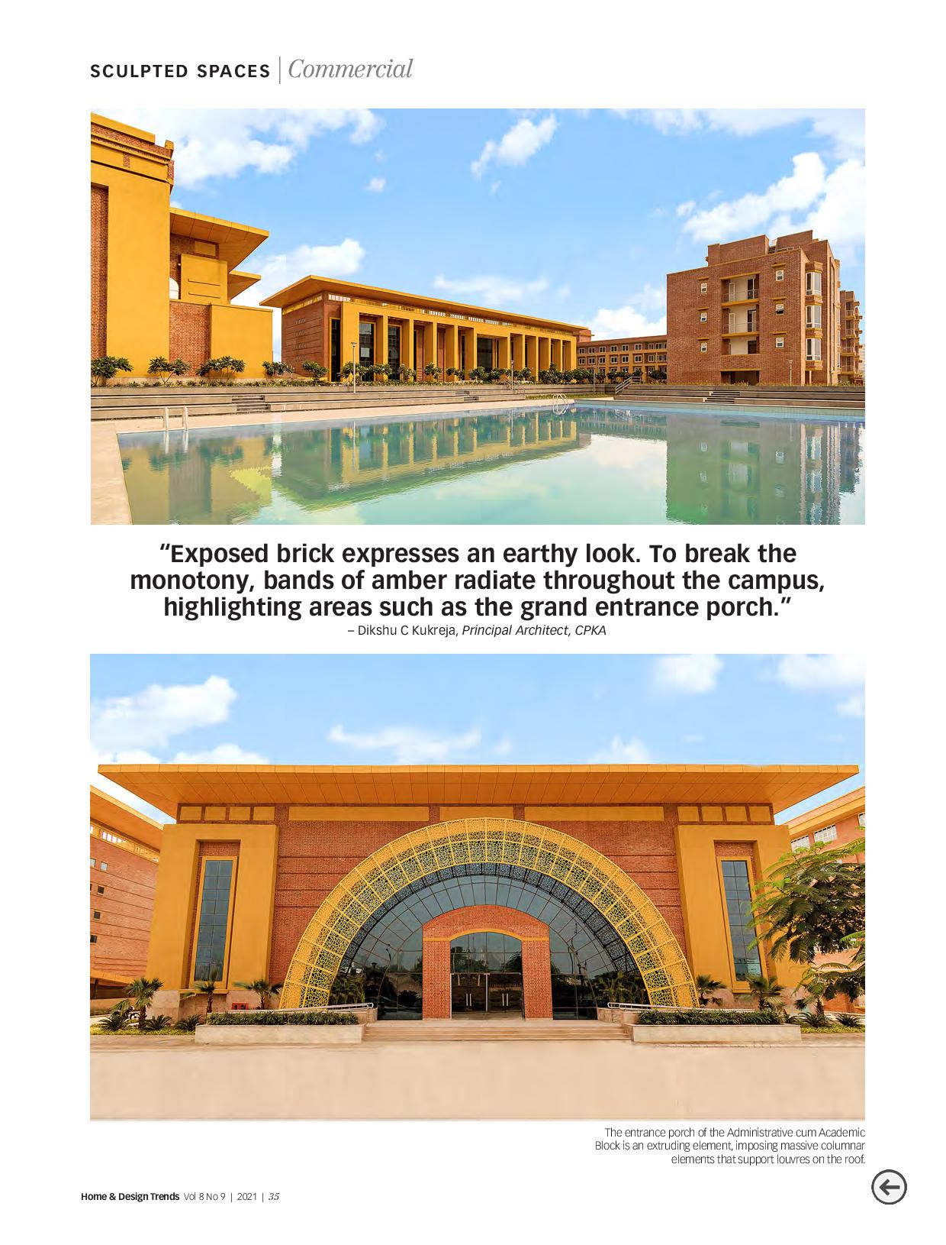









https://www.hindustantimes.com/india-news/ayodhyas-transformation-in-spotlight-as-development-projects-pick-up-pace-101689187616619.html

https://theprint.in/india/mp-work-on-108-ft-tall-statute-of-adi-shankaracharya-begins-at-omkareshwar/1558470/
https://www.bhaskar.com/local/mp/khandwa/news/ekatmdham-in-omkareshwar-updates-prime-minister-narendra-modi-will-unveil-the-statue-of-adi-guru-shankaracharya-131250845.html?_branch_match_id=1183276761788472499&utm_campaign=131250845&utm_medium=sharing&_branch_referrer=H4sIAAAAAAAAA8soKSkottLXT0nMzMvM1k3Sy8zTN%2FHOdE90NC%2BsqkoCAAYqreQfAAAA
https://www.latestly.com/agency-news/india-news-mp-work-on-108-ft-tall-statute-of-adi-shankaracharya-begins-at-omkareshwar-5106219.html/amp

https://www.youtube.com/live/bRkmkSVH748?feature=share
https://news.abplive.com/technology/ai-aec-sector-artificial-intelligence-building-design-construction-1615579
https://youtu.be/2OX2blMlO7E
https://www.youtube.com/live/DsVs3bdVUTc?feature=share
https://www.mid-day.com/amp/brand-media/article/future-ready-design-for-the-iconic-indian-army-headquarter-by-the-poster-boy-23295218
https://youtu.be/81BW2XEFLog

https://www.ptinews.com//news/west/mp-work-on-108-ft-tall-statute-of-adi-shankaracharya-begins-at-omkareshwar/564759.html

https://www.republicworld.com/india-news/general-news/mp-work-on-108-ft-tall-statute-of-adi-shankaracharya-begins-at-omkareshwar-articleshow.html
https://theprint.in/ground-reports/marble-glass-steel-indian-architects-caught-between-desires-of-cash-rich-climate-alarm/1672763/
https://twitter.com/ThePrintIndia/status/1680842589065613313
https://www.rprealtyplus.com/interviews/ai-impacts-every-sector-of-society-111439.html

https://www.aajtak.in/madhya-pradesh/story/statue-of-oneness-madhya-pradesh-tallest-statue-to-be-built-in-omkareshwar-lcln-1612610-2023-01-10

https://www.latestly.com/agency-news/india-news-mp-work-on-108-ft-tall-statute-of-adi-shankaracharya-begins-at-omkareshwar-5106219.html/amp
https://www.devdiscourse.com/article/entertainment/2441538-mp-work-on-108-ft-tall-statute-of-adi-shankaracharya-begins-at-omkareshwar
https://www.theweek.in/wire-updates/national/2023/05/05/bes11-mp-shankaracharya-statue.html
https://www.newsdrum.in/national/mp-work-on-108-ft-tall-statute-of-adi-shankaracharya-begins-at-omkareshwar
https://www.news18.com/india/work-on-108-feet-tall-adi-shankaracharya-statute-begins-at-omkareshwar-pm-modi-likely-to-inaugurate-in-sept-7748239.html

